**SECTION ONE: MULTIPLE CHOICE** **(20 marks)**

Record an answer for questions 1 – 20 by marking your choice on the separate Multiple-Choice Answer Sheet using a blue or black pen or a B or 2B pencil. Each question is worth one mark.

If you make an error, follow the instructions given to you on the Multiple-Choice Answer Sheet.

Suggested working time for this section is 20 minutes.

1. During the backswing phase of a football kick, the leg is drawn behind the body prior to the forward swing of the leg. When the leg is drawn behind the body, which of the following movements occurs at the hip joint?

(a) flexion

(b) extension

(c) abduction

(d) adduction

2. A tennis player who creates a visual representation of themselves extending at the

elbow just prior to serving is an example of imagery and

1. stress.
2. self-confidence.
3. arousal.
4. concentration.

3. In an 800m running race, the finish line (when starting in lane 1) is also the start line. What does 800m represent?

(a) velocity

(b) distance

(c) displacement

(d) angular displacement

4. An athlete underwent an extensive period of anaerobic training. During this period, they ran varying distances no longer than 400m and typically at a very high intensity. Which of the following chronic adaptations would be least likely to occur?

(a) an increase in the number and size of mitochondria

(b) an increase in glycolytic enzymes

(c) an increase in ATP-PC stores

(d) an increased tolerance of lactic acid

5. Whilst playing in the French Open tennis final, Rafael Nadal sees his shot hit the line, causing a puff of white powder to appear from the line marking. What source of feedback is Rafael receiving in this instance?

(a) concurrent

(b) internal

(c) external intrinsic

(d) external augmented

6. A muscle directly involved in causing a segment to move is called the

(a) agonist

(b) antagonist

(c) stabiliser

(d) controller

7. The following table represents a training day for a 3000m runner.

|  |  |  |  |  |
| --- | --- | --- | --- | --- |
| **Set** | **Reps** | **Distance** | **Time to complete repetition** | **Rest (between reps)** |
| 1 | 6 | 400m | 75 seconds | 90 seconds; jog/walk |
| 2 | 6 | 600m | 120 seconds | 150 seconds; jog/walk |

What type of training method is the athlete using?

(a) continuous

(b) fartlek

(c) interval

(d) plyometrics

8. The image below shows a golf driving range with 3 different levels. If the same golfer hit the same drive, with the same golf club, from each of the different heights, which of the following statements would be true? The shot would travel the

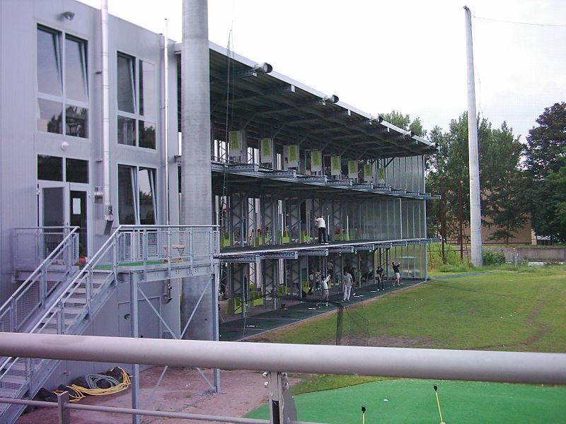

(a) furthest from the bottom level

(b) furthest from the middle level

(c) furthest from the upper level

(d) same distance irrespective of level

9. According to Nideffer’s Model of Attentional control, which of the following athletes would be described as ‘internal and narrow’?

1. Tour de France rider
2. rugby player
3. netballer
4. golfer

10. The type of activity an athlete participates in is likely to affect the optimal arousal level required for optimum performance. Which of the following is likely to represent the different arousal curves in the diagram below:

**2**

**1**

**4**

**3**

**Performance**

**Arousal**

(a) 1 – archery, 2 – blocking in football, 3 – penalty kick in soccer, 4 – volleyball spike

(b) 1 – archery, 2 – volleyball spike, 3 – penalty kick in soccer, 4 – blocking in football

(c) 1 – blocking in football, 2 – volleyball spike, 3 – penalty kick in soccer, 4 – archery

(d) 1 – archery, 2 – penalty kick in soccer, 3 – volleyball spike, 4 – blocking in football

11. In preparation for an upcoming event, two athletes engage in a 2km training run and both run at the same speed. Athlete A has just started training and is considered relatively unfit whilst Athlete B has been training for months and is reaching peak condition. At the 1km point of the run, which of the following statements is most likely to be correct?

(a) The cardiac output of Athlete A is likely to be significantly higher than Athlete B.

(b) Athlete A would have a lower heart rate than Athlete B due to a higher stroke volume.

(c) Athlete B would have a lower heart rate than Athlete B due to a higher stroke volume.

(d) The cardiac output of Athlete B is likely to be significantly higher than Athlete A.

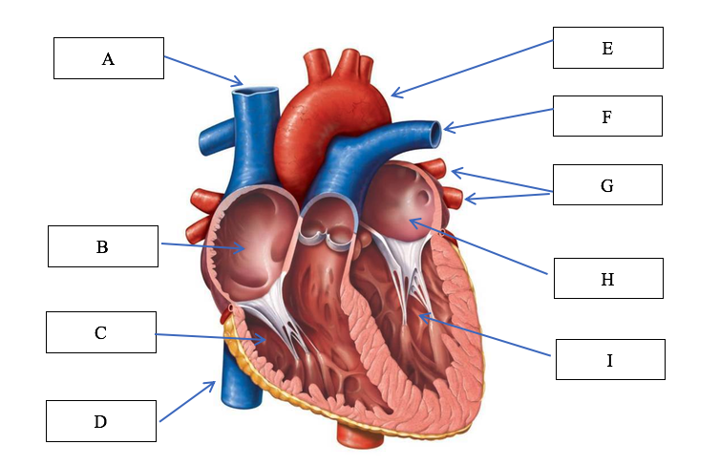12. Which of the following options correctly identifies the structures of the heart?

(a) A: Vena cava, B: right atrium, C: right ventricle, E: aorta, F: pulmonary vein: left atrium, G: pulmonary artery

(b) A: Vena cava, B: right atrium, C: right ventricle, E: aorta, F: pulmonary artery,

G: pulmonary vein

(c) B: left atrium, C: left ventricle, D: vena cava, E: aorta, H: right atrium, I: right ventricle

(d) B: left ventricle, C: left atrium, D: vena cava, E: aorta, H: right ventricle, I: right atrium

13. An athlete who listens to high tempo music and uses positive self-talk prior to a performance is most likely trying to regulate

(a) self-confidence

(b) concentration

(c) arousal

(d) stress and anxiety

14. The day after a failed attempt at the Red Bull Cliff Diving, an athlete is told by her coach that she needed to get into her tuck earlier to allow for full extension prior to hitting the water. This feedback is

(a) external augmented, knowledge of performance, terminal.

(b) external augmented, knowledge of performance, concurrent.

(c) external intrinsic, knowledge of performance, terminal.

(d) external augmented, knowledge of result, concurrent.

15. During a 400m running sprint, there is a transition period in which the Anaerobic Glycolysis system takes over from the ATP-PC system as the dominant provider of ATP. This typically occurs after approximately

(a) 1-5 sec

(b) 5-10 sec

(c) 20-30 sec

(d) 30-40 sec

16. If velocity is constant, then acceleration must be

(a) increasing.

(b) decreasing.

(c) zero.

(d) none of the above.

17. The following table represents a phase of a resistance training program for an elite rugby player.

|  |  |  |  |
| --- | --- | --- | --- |
| **Weight** | **Sets** | **Reps** | **Rest (between sets)** |
| 90% 1RM | 3 | 4-6 | 3 minutes |

Which fitness component does this phase of the training program specifically target?

(a) aerobic power

(b) muscular endurance

(c) muscular strength

(d) muscular power

18. Within Fitts and Posner’s Model of learning, which stage is associated with the highest requirement for thought processing in relation to performing a task?

(a) cognitive stage

(b) association stage

(c) autonomous stage

(d) associate stage

19. A professional athlete is competing in an Olympic Weightlifting competition. She has five minutes before her final lift and needs to register a personal best to win the gold. To ensure optimal arousal levels, what wouldn’t you recommend she do?

1. use relaxation techniques such as meditation to reduce arousal levels
2. use imagery to recreate a past successful performance and increase arousal levels
3. use the same pre performance routine she has used in all her previous attempts

(d) use positive self-talk to increase arousal levels

20. A penalty kick in soccer is a skill considered to be

(a) open, gross and discrete.

(b) closed, fine and discrete.

(c) open, fine and discrete.

(d) closed, gross and discrete.

**SECTION ONE: MULTIPLE CHOICE** **(20 marks)**

Record an answer for questions 1 – 20 by marking your choice on the separate Multiple-Choice Answer Sheet using a blue or black pen or a B or 2B pencil. Each question is worth one mark.

If you make an error, follow the instructions given to you on the Multiple-Choice Answer Sheet.

Suggested working time for this section is 20 minutes.

1. During energy system interplay:

(a) all three energy systems contribute to ATP production however, at any stage, one of them is the main contributor.

(b) all three energy systems supply energy continuously.

(c) the two anaerobic energy systems have been exhausted and most energy is derived from the aerobic energy system.

(d) all three energy systems work sequentially.

2. Feedback about the outcome of a performance such as seeing your time for a 100-metre running sprint is known as:

(a) knowledge of outcome

(b) knowledge of performance

(c) knowledge of results

(d) knowledge of success

3. In which of the following examples is Newton’s third law most evident?

(a) Rowing a boat

(b) Performing a handstand

(c) Applying spin to a soccer ball

(d) Giving with the ball when catching a cricket ball

4. In which of the following examples is Newton’s 1st law most evident?

(a) Rowing a boat in circles

(b) Putting all your force into a pull shot in cricket

(c) A cue ball moving towards the cushion

(d) Giving with the ball when catching a cricket ball

5. When a learner decides on or develops a motor program based on information input, they are likely to be in which stage of the information processing model?

(a) Identification of stimuli/input

(b) Response identification/decision making

(c) Response/output

(d) Feedback

6. During a submaximal continuous activity (70% max HR) lasting 90 minutes, the majority of the ATP is resynthesised by breaking down:

(a) fats

(b) creatine phosphate

(c) protein

(d) carbohydrates

7. A muscle directly involved in causing a segment to move is called the

(a) agonist

(b) antagonist

(c) stabiliser

(d) controller

8. Positive self-talk techniques are mostly used during performance. When self-belief is low, athletes are more likely to engage in negative self-talk, however when performance is high, they are more likely to use positive self-talk. What role does positive self-talk play in improving performance?

(a) To remind the athlete of outcome goals they are hoping to achieve

(b) To reset the athlete’s emotions

(c) To increase the athlete’s self confidence

(d) To distract the athlete from negative thoughts reaching their mind

9. Fartlek training:

(a) include predetermined work:rest ratios

(b) should be overloaded by completing an increased distance in a slower time

(c) must include regular rest periods to restore phosphate creatine levels

(d) combines continuous activity with short bursts of intense work at irregular intervals

10. A softball player has two bats, one of which is 300 grams heavier than the other. If the player swings both bats at the same velocity, the heavier bat will be able to produce greater ________ than the lighter bat.

(a) acceleration

(b) momentum

(c) force

(d) torque

11. Diving off a swimming block is an example of:

(a) a discrete motor skill

(b) a serial motor skill

(c) a continuous motor skill

(d) an open motor skill

12. The arteriovenous oxygen (a-vO2) difference:

(a) plateau's when VO2 max is reached

(b) decreases in response to increased exercise loads

(c) increases in response to increased exercise loads

(d) is only fuelled by the aerobic energy system

13. Jackie is about to play her first Women’s AFL game following an ACL knee injury. She is feeling nervous about kicking the ball because she's afraid she might reinjure her knee. Which of the following techniques would be useful for Jackie before the game?

(a) Practicing mental imagery

(b) Using strategies to increase her arousal levels

(c) Using strategies to decrease her arousal levels

(d) Deep centred breathing

14. Two athletes, standing side by side, weigh the exact same amount. Athlete A is 1.80m while Athlete B is 1.65m. Based on this, Athlete A will have a:

(a) improved base of support

(b) higher centre of gravity

(c) lower centre of gravity

(d) higher amount of inertia

15. In preparation for major sporting events, coaches will often implement variety into their training programs in order to try and mitigate reduced motivation in athletes. Which of the following training principles need to be closely considered when introducing variety?

(a) Progressive overload

(b) Intensity

(c) Duration

(d) Specificity

16. Why might an athlete fluctuate between the associative and autonomous stage of learning?

(a) They don't fluctuate between the two stages, they can only be in one stage

(b) They fail to listen to feedback their coach is giving them

(c) They lose self-confidence and therefore move back to the associate stage

(d) As they learn new skills, they need to practice them to become autonomous

17. If an athlete’s final velocity is less than their initial velocity, their acceleration must be:

(a) zero

(b) negative

(c) positive

(d) unknown

18. In training, an athlete completes the following training activity

**Sprint 100m**

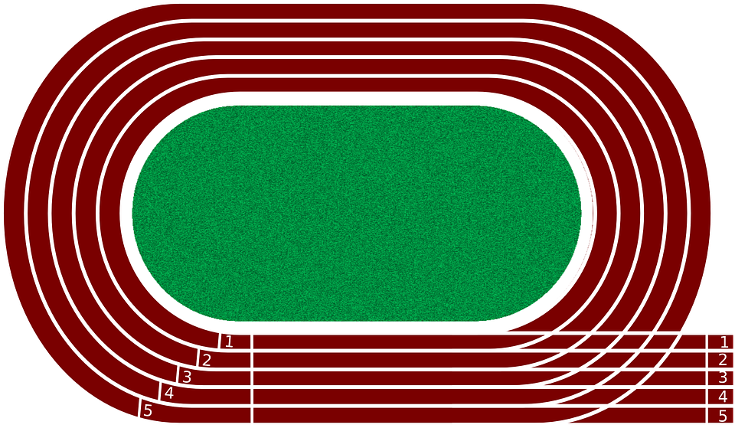

**Walk 100m (recovery)**

**Walk 100m (recovery)**

**Sprint 100m**

What type of training does this activity represent?

(a) Aerobic fartlek

(b) Aerobic interval

(c) Anaerobic fartlek

(d) Anaerobic interval

19. An elite level tennis player who analyses the stance, grip, service position and ball toss of their opponent is utilising which type of cue/cues to improve performance?

(a) Visual

(b) Verbal

(c) Proprioceptive

(d) All of the above

20. The muscle responsible for opposing movements to the prime mover muscle are called:

(a) agonist

(b) antagonist

(c) synergist

(d) reciprocal inhibition

**SECTION ONE: MULTIPLE CHOICE** **(20 marks)**

Record an answer for questions 1 – 20 by marking your choice on the separate Multiple-Choice Answer Sheet using a blue or black pen or a B or 2B pencil. Each question is worth one mark.

If you make an error, follow the instructions given to you on the Multiple-Choice Answer Sheet.

Suggested working time for this section is 20 minutes.

1. In athletics, a 400m race lasting approximately 60sec is fuelled by:

(a) the ATP/PC system with small contributions from the anaerobic glycolysis system

(b) the anaerobic glycolysis system with limited contribution from the aerobic energy system

(c) relatively equal contributions from the anaerobic and aerobic energy systems

(d) the aerobic energy system with small contribution from the anaerobic glycolysis system

2. Angular motion is:

(a) where all the parts of a body move through a rotational pathway, through the same angle, in different directions and at the same time

(b) where all the parts of a body move through a rotational pathway, through the same angle, in the same direction and at the same time

(c) where all the parts of a body move through a rotational pathway, through different angles, in the same direction and at the same time

(d) a combination of linear and general motion

3. Skills performed by athletes are categorised using a number of different classification systems. Bowling a ball in cricket is best classified as a:

(a) fine skill and a discrete skill

(b) motor skill and an open skill

(c) continuous skill and a closed skill

(d) gross skill and a serial skill

4. During her debut WAFL game, Lisa is given a free kick. In preparing for her kick, she quickly scans the field for a teammate to kick to, but then opts to kick for a goal. The changing of Lisa’s attentional focus would require her to move from:

(a) broad external to narrow external

(b) broad internal to narrow external

(c) narrow internal to broad external

(d) narrow external to broad internal

5. Use the table to identify the muscles labelled below.

|  |  |  |  |  |
| --- | --- | --- | --- | --- |
|  | i) | ii) | iii) | iv) |
| (a) | Pectoralis | Triceps | Quadriceps | Latissimus |
| (b) | Pectoralis | Deltoid | Adductors | Latissimus |
| (c) | Pectoralis | Deltoid | Abductors | Latissimus |
| (d) | Triceps | Deltoid | Abductors | Gluteus Maximus |

6. Complete the table below to show how the tidal volume, respiratory rate, and stroke volume change during exercise.

|  |  |  |
| --- | --- | --- |
| **Volume name** | **Value at rest** | **Change during exercise (increase, decrease, no change)** |
| Tidal volume | 500cm3 | i |
| Respiratory rate | 16 breaths per minute | ii |
| Stroke volume | 70mL | iii |

(a) i) Increase ii) decrease iii) increase

(b) i) Increase ii) increase iii) increase

(c) i) No change ii) increase iii) decrease

(d) i) No change ii) increase iii) increase

7. When referring to the summation of forces for maximum force development, which one of the following statements is incorrect?

(a) Each segment must make an optimum contribution before the next body part begins its movement

(b) As many body parts (segments) as possible should be recruited

(c) Body segments are sequenced from small to large

(d) Athletes should follow through towards the target to prevent the deceleration of the final segment.

8. During a training session, a swimming coach holds up split times on a whiteboard at the side of the pool for the athlete to see. This is an example of:

(a) proprioceptive feedback

(b) terminal feedback

(c) knowledge of performance feedback

(d) concurrent feedback

9. The optimal level of arousal varies based on the activities being performed. Which of the following statements is most correct?

(a) Fine motor skills generally require higher levels of arousal

(b) Athletes participating in activities that involve rapid decision-making benefit from high levels of arousal

(c) Athletes participating in activities requiring broad attentional focus benefit from lower levels of arousal

(d) Gross motor skills generally require lower levels of arousal

10. The most likely cause of fatigue in a 100m running sprint is:

(a) the accumulation of hydrogen ions

(b) the accumulation of lactic acid

(c) the depletion of creatine phosphate stores

(d) dehydration

11. When throwing a javelin for maximal distance, providing that all else remains constant, a taller person will:

(a) throw at the same angle

(b) throw at an increased angle

(c) throw at a reduced angle

(d) throw at 45 degrees

12. During exercise, blood flow is diverted from some organs. Which organs are likely to receive less blood flow during exercise?

(a) Heart and the kidneys

(b) Skeletal muscles and the brain

(c) Skin and the small intestine

(d) Small intestine and the kidneys

13. During a hamstring curl (pictured below), ______________ takes place at the knee joint during the lifting phase.

(a) flexion

(b) extension

(c) abduction

(d) adduction

14. The Information Processing Model is a four-stage process which describes how athletes receive information and produce a response. The input stage of the Information Processing Model refers to:

(a) gathering information about the environment

(b) organising information which has been picked up by the senses

(c) performing a skill in a changing environment

(d) receiving feedback post performance

15. A rugby player wishing to maintain balance against the force of his opponent should:

(a) lower his centre of gravity, decrease his base of support, and keep his line of gravity as close as possible to the direction of the oncoming force

(b) lower his centre of gravity, decrease his base of support, and keep his line of gravity as far as possible from the direction of the oncoming force

(c) lower his centre of gravity, increase his base of support, and keep his line of gravity as close as possible to the direction of the oncoming force

(d) lower his centre of gravity, increase his base of support, and keep his line of gravity as far as possible from the direction of the oncoming force

16. A number of sports such as boxing and horse racing require athletes to ‘make weight’ prior to their event. This often involves a period of rapid weight loss, usually achieved by deliberately dehydrating the athlete, and is linked with which health related component of fitness?

(a) Cardiorespiratory endurance

(b) Muscular strength

(c) Muscular endurance

(d) Body composition

17. The graph below shows a swimmer’s depth and rate of breathing at rest. Identify, using the data in figure 1, the name of the lung volume labelled A.

(a) Minute Ventilation

(b) Respiratory rate

(c) Vital capacity

(d) Tidal volume

18. Which of the following provides the best example of an athlete utilising proprioceptive cues to improve their performance?

(a) A tennis player changing her shot last minute after seeing the opponent lose their footing.

(b) A snowboarder adjusting their body position and plantar flexing their ankles during a turn to avoid falling.

(c) A Formula One driver taking a wide line into a corner after seeing dirt and debris on the inside of the upcoming corner.

(d) A basketball player making a no look pass after hearing a teammates call.

19. The following table contains part of a weights training program that a prospective soccer player was using to improve his _________________ in his arms and legs prior to the start of the soccer season.

|  |  |  |  |
| --- | --- | --- | --- |
| **Exercise** | **Sets** | **Repetitions** | **Resistance** |
| Seated leg press | 4 | 4-6 | 85% 1 repetition maximum |
| Military press | 5 | 3-5 | 90% 1 repetition maximum |
| Bicep curl | 4 | 4-6 | 85% 1 repetition maximum |
| Leg curl | 4 | 4-6 | 85% 1 repetition maximum |
| Leg extension | 6 | 3-5 | 90% 1 repetition maximum |
| Triceps extension | 5 | 3-5 | 90% 1 repetition maximum |

(a) muscular power

(b) muscular endurance

(c) muscular strength

(d) cardiorespiratory endurance

20. Use the table to identify the bones on the skeleton below.

ii

iv

iii

i

|  |  |  |  |  |
| --- | --- | --- | --- | --- |
|  | i) | ii) | iii) | iv) |
| (a) | Ulna | Radius | Tibia | Fibula |
| (b) | Radius | Ulna | Fibula | Tibia |
| (c) | Radius | Ulna | Tibia | Fibula |
| (d) | Ulna | Radius | Fibula | Tibia |

**SECTION ONE: MULTIPLE CHOICE** **(20 marks)**

Record an answer for questions 1 – 20 by marking your choice on the separate Multiple-Choice Answer Sheet using a blue or black pen or a B or 2B pencil. Each question is worth one mark.

Suggested working time for this section is 20 minutes.

1. Velocity is calculated by

(a) dividing distance travelled by time taken.

(b) dividing displacement by time taken.

(c) multiplying distance travelled by time taken.

(d) multiplying displacement by time taken.

2. A defender increases their velocity as they run towards an opposition player. The ball changes possession and the defender becomes an attacker. They slow down to change direction towards their goal and then increase their velocity again to make ground towards the scoring end. The acceleration of the player as they perform these movements is best described as

(a) positive acceleration then negative acceleration then positive acceleration.

(b) positive acceleration then negative acceleration.

(c) negative acceleration then positive acceleration.

(d) positive acceleration then zero acceleration then positive acceleration.

3. A baseball player fields the ball near second base and must get the ball to first base as quickly as possible to get the batter out. The player should throw with a

(a) high trajectory and high velocity.

(b) flat trajectory and high velocity.

(c) release angle of 45 degrees.

(d) high trajectory and low velocity.

4. When an object is thrown from a height that is greater than the landing height, the optimal angle of release to reach maximum distance is

(a) 45 degrees.

(b) greater than 45 degrees.

(c) less than 45 degrees.

(d) 90 degrees.

5. Velocity is calculated by

(a) dividing distance travelled by time taken.

(b) dividing displacement by time taken.

(c) multiplying distance travelled by time taken.

(d) multiplying displacement by time taken.

6. Blood enters the heart from the inferior and superior vena cava into which chamber?

(a) Left atrium

(b) Right atrium

(c) Left ventricle

(d) Left ventricle

7. The major components of blood are

(a) Plasma, red blood cells, erythropoietin and platelets

(b) Plasma, waste, enzymes and platelets

(c) Red blood cells, white blood cells, plasma and platelets

(d) Red blood cells, erythropoietin, plasma and oxygen

8. What carries deoxygenated blood from the right side of the heart to the lungs

(a) Pulmonary veins

(b) Pulmonary arteries

(c) Aorta

(d) Right ventricle

9. What vessels allow oxygen and nutrients into the cells and carbon dioxide to pass out

(a) Veins

(b) Arteries

(c) Capillaries

(d) Blood vessels

|  |  |  |
| --- | --- | --- |
| 10. | Open skills are; | |
| a) | | Are self-paced | |
| b) | | Vary depending on the requirements of the activity or game | |
| c) | | Allow the person to repeat the same executive program or movement pattern | |
| d) | | Are performed where the conditions remain unchanged | |

|  |  |  |
| --- | --- | --- |
| 11. | Learning can be broken down into three stages. At the associative stage; | |
| a) | | The learner/performer can execute skills without thinking about the steps involved | |
| b) | | Most time is spent on tactics and strategies related to the performance | |
| c) | | Errors are smaller but occur more frequently than at the autonomous stage | |
| d) | | Errors are smaller and occur more frequently than at the cognitive stage | |

|  |  |  |
| --- | --- | --- |
| 12. | Swimming is an example of a motor skill classification type known as: | |
| a) | | Discrete | |
| b) | | Serial | |
| c) | | Fine | |
| d) | | Continuous | |

|  |  |  |
| --- | --- | --- |
| 13. | Cricket uses white balls for day-night matches and red balls for Test matches played only in daylight. In the information processing model, the use of different coloured balls is to enhance the: | |
| a) | | Identification of stimulus/input phase | |
| b) | | Response identification/decision-making phase | |
| c) | | Response/output phase | |
| d) | | Feedback phase | |

|  |  |  |
| --- | --- | --- |
| 14. | Effective feedback includes which of the following? | |
| a) | | Specific, Sooner, Positive, Constructive and Informative | |
| b) | | General, Later, Negative, Destructive and Meaningless | |
| c) | | Specific, General, Positive, Later and Informative | |
| d) | | Specific, Informative, Sooner, Positive and General | |

|  |  |  |
| --- | --- | --- |
| 15. | Which of the following coaching methods would be most effective when introducing a beginner to a complex skill? | |
| a) | | Visual demonstration of the task emphasizing the most critical elements | |
| b) | | Brief verbal description of the task | |
| c) | | Visual demonstration with detailed verbal description of the biomechanical principles involved. | |
| d) | | Detailed verbal description of the task | |

|  |  |  |
| --- | --- | --- |
| 16. | Knowledge of performance for a golf swing occurs: | |
| a) | | When this is reviewed as a video replay that includes slowing down key parts of the swing | |
| b) | | If the golfer compares the action to previous actions and knows what ‘feels right’ | |
| c) | | After the club professional has provided feedback and offered suggestions regarding body movements | |
| d) | | All of the above | |

|  |  |  |
| --- | --- | --- |
| 17. | If a skill is being demonstrated by a coach or an expert performer, it must be: | |
| a) | | Suitable to the skill and learning level of the performer | |
| b) | | Performed at an appropriate speed at which the learner can follow | |
| c) | | Demonstrated an adequate number of times so key elements are understood | |
| d) | | All of the above | |

|  |  |  |
| --- | --- | --- |
| 18. | When coaching someone at the associative level, it is important to: | |
| a) | | Allow for experimentation and discovery where performers come up with the best ways of performing skills | |
| b) | | Aim for personal best performances to keep motivation high whilst success levels might be inconsistent | |
| c) | | Keep sessions short to cater for lower concentration and fitness levels | |
| d) | | Use sophisticated language and technical terms | |

|  |  |  |
| --- | --- | --- |
| 19. | Which one of these is a fine motor skill? | |
| a) | | Tackle in a game of rugby | |
| b) | | Short serve in badminton | |
| c) | | Hit in hockey | |
| d) | | Shot on goals in football | |

1. The purpose of feedback is to:
2. provide constructive criticism.
3. reinforcement of gross motor errors.
4. increase motivation.
5. reinforcement of fine motor control.

**SECTION ONE: MULTIPLE CHOICE** **(20 marks)**

Record an answer for questions 1 – 20 by marking your choice on the separate Multiple-Choice Answer Sheet using a blue or black pen or a B or 2B pencil. Each question is worth one mark.

If you make an error, follow the instructions given to you on the Multiple-Choice Answer Sheet.

Suggested working time for this section is 20 minutes.

1. 45 seconds into a 1500m run, which energy system would be providing the highest proportion of energy for ATP production?

(a) ATP-CP  
(b) Lactic Acid  
(c) Aerobic  
(d) Anaerobic

2. An increase in cardiac output is a direct response of the increase in both:

(a) blood pressure and tidal volume

(b) blood pressure and stroke volume

(c) heart rate and tidal volume

(d) heart rate and stroke volume

3. An elite junior basketball player wanting to improve their vertical leap and rebounding ability would be best advised to undertake:

(a) fartlek training

(b) continuous training

(c) interval training

(d) plyometric training

4. Rate of perceived exertion, percentage of heart rate maximum and percentage of VO2 maximum are all valid measures for which principle of training?

(a) specificity

(b) intensity

(c) duration

(d) progressive overload

5. After completing a battery of fitness tests, an athlete was able to identify his strengths and weaknesses in the table below.

|  |  |
| --- | --- |
| **Strengths** | **Weaknesses** |
| * Agility * Balance * Reaction time | * Muscular strength * Power * Speed * Cardiorespiratory endurance |

Based on the results in the table above, the athlete is most likely a:

(a) long distance runner

(b) mixed martial artist

(c) surfer

(d) shot putter

6. Which of the following is **not** a long-term adaptation to physical activity?

1. Decrease in resting heart rate.
2. Decrease in stroke volume at rest.
3. Decrease in cardiac output at rest.
4. Increase in blood volume at rest.

7. The primary energy system used during a javelin throw is:

1. Aerobic energy system.
2. Lactic acid energy system.
3. Anaerobic glycolysis energy system.
4. ATP-CP energy system.

8. In their first session, a personal trainer asks their client to perform as many push ups as possible in one minute. This test is designed to primarily measure the client’s:

1. Muscular strength.
2. Cardiorespiratory endurance.
3. Power.
4. Muscular endurance.

9. The athletes in the picture below are participating in which type of training?

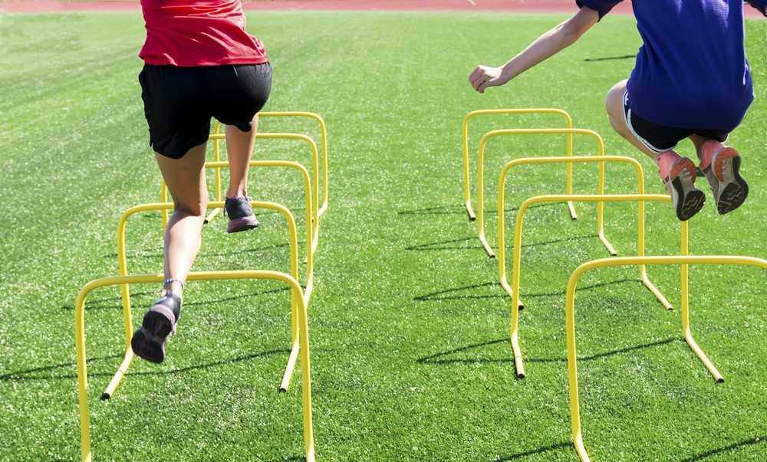

1. Flexibility training.
2. Plyometric training.
3. Fartlek training.
4. Interval training.

10. “If you don’t use it, you lose it” best describes which training principle?

1. Intensity.
2. Specificity.
3. Progressive overload.
4. Reversibility.

11. Cardiac Output is a product of:

1. Blood Pressure x Heart Rate (beats per minute)
2. Blood Pressure x Stroke Volume
3. Stroke Volume x Heart Rate (beats per minute)
4. Diastole x Systole

12. The energy used by muscles to contract and produce movement comes from a chemical called:

1. Adenosine Triphosphate (ATP)
2. Creatine Phosphate (CP)
3. Adenosine Diphosphate (ADP)
4. Lactic Acid

13. The energy used by a runner to complete a 400m sprint is primarily provided by the:

1. Aerobic System
2. Lactic Acid System
3. Muscles stores of ATP
4. ATP-CP System

14. In completing their event a 5000m runner obtains energy for their muscles:

1. From their aerobic energy system
2. From their anaerobic energy systems
3. From an even contribution by the aerobic and anaerobic pathways
4. Primarily from their aerobic energy system with some contribution from their anaerobic energy systems

15. In the sport of rugby, the ball carrier has to react to the defence quickly, often changing his initial running direction. This is a characteristic of which component of fitness?

1. Muscular strength
2. Agility
3. Muscular power
4. Flexibility

16. The primary food fuel for energy production during high intensity physical activity is

1. PC
2. Protein
3. Fats
4. Carbohydrates

17. ‘You get what you train for’ is a phrase that could be expressed more correctly by the term:

1. Overload
2. Specificity
3. Intensity
4. Training effect

18. For an athlete to increase muscular strength, he/she should:

1. Use heavy weights with many repetitions
2. Use light weights with many repetitions
3. Use heavy weights with few repetitions
4. Use lights weights with few repetitions

19. Which of the following are both an immediate response and a long-term adaptation to exercise?

1. Increased stroke volume
2. Increased blood flow to the muscles
3. Increased arterial *–* venous *O2* difference
4. All of the above

20. An athlete is said to be in oxygen deficit when their oxygen uptake is:

1. less than the oxygen required to produce sufficient energy aerobically
2. greater than the oxygen required to produce sufficient energy aerobically
3. equal to oxygen required to produce sufficient energy aerobically
4. below resting oxygen levels to produce energy aerobically

**SECTION ONE: MULTIPLE CHOICE** **(20 marks)**

Record an answer for questions 1 – 20 by marking your choice on the separate Multiple-Choice Answer Sheet using a blue or black pen or a B or 2B pencil. Each question is worth one mark.

If you make an error, follow the instructions given to you on the Multiple-Choice Answer Sheet.

Suggested working time for this section is 20 minutes.

1. Which one of the following reactions summarising anaerobic energy production is correct?
2. Glucose → Energy + Oxygen
3. Sucrose → Energy + Lactic Acid
4. Glucose + Oxygen → Energy + Carbon Dioxide
5. Glucose → Energy + Lactic Acid
6. Which one of the following correctly identifies E.P.O.C?
7. Extra Pure Oxygen Calories
8. Extra Pure Oxygen Consumption
9. Excess Post-Exercise Oxygen Consumption
10. Excess Post-Exercise Oxygen Calories
11. Which one of the following statements about EPOC is correct?
12. EPOC occurs because of aerobic exercise
13. EPOC removes lactic acid
14. EPOC occurs in anticipation of exercise
15. EPOC prevents sweating
16. Which one of the following statements about the immediate effects of exercise is NOT correct?
17. Heart rate increases
18. Breathing rate increases
19. Oxygen levels increase
20. Temperature increases
21. Which one of the following is correct about bradycardia?
22. Bradycardia is a reduced resting heart rate
23. Bradycardia is an increased stroke volume
24. Bradycardia is an increased cardiac output
25. Bradycardia is an increase in heart muscle
26. Which one of the following is the correct definition of balance?
27. The ability to keep your mass stable
28. The ability to keep your base of support in the centre of your balance
29. The ability to maintain your base of support table
30. The ability to maintain the centre of mass over the base of support
31. In which one of the following activities is balance an important fitness component?
32. 100-metre sprint
33. Springboard diving
34. Gymnastics beam routine
35. Rowing
36. Which one of the following fitness components is defined as the ability of the heart and lungs to supply oxygen to the working muscles?
37. Flexibility
38. Cardio-vascular endurance
39. Balance
40. Co-ordination
41. Which one of the following fitness components is defined as the ability to use different (two or more) parts of the body together smoothly and efficiently?
42. Flexibility
43. Reaction time
44. Balance
45. Co-ordination
46. Which one of the following is the correct definition of co-ordination?
47. The ability to catch and hit balls efficiently
48. The ability to use the arms and legs to move efficiently
49. The ability to use different parts of the body together smoothly and efficiently
50. The ability to move easily and quickly into positions
51. In which one of the following activities is co-ordination an important fitness component?
52. Goalkeeping
53. Springboard diving
54. Gymnastics beam routine
55. Rowing
56. Which one of the following fitness components is defined as the range of movement possible at a joint?
57. Flexibility
58. Reaction time
59. Balance
60. Co-ordination
61. Which one of the following fitness components is defined as the ability of a muscle to undergo repeated contractions avoiding fatigue?
62. Flexibility
63. Muscular endurance
64. Balance
65. Co-ordination
66. Which one of the following is the correct definition of muscular endurance?
67. The ability of a group of muscles to contract efficiently
68. The ability of a muscle group to delay fatigue
69. The ability of a group of muscles to contract repeatedly
70. The ability of a muscle to undergo repeated contractions and avoid fatigue.
71. Which one of the following fitness components is defined as the product of strength and speed?
72. Flexibility
73. Muscular strength
74. Power
75. Co-ordination
76. In which one of the following activities is power NOT an important fitness component?
77. Rugby scrum
78. Springboard diving
79. Gymnastics balance
80. Rowing
81. Which one of the following is the correct definition of reaction time?
82. The time taken to complete a response
83. The time taken to initiate a stimulus
84. The time taken to react
85. The time taken to initiate a response to a stimulus
86. In which one of the following activities is reaction time an important fitness component?
87. Rugby scrum
88. Springboard diving
89. Basketball shooting
90. Rowing
91. Which one of the following fitness components is defined as the maximum rate at which an individual is able to perform a movement?
92. Speed
93. Reaction time
94. Power
95. Co-ordination
96. Which one of the following tests would you use to measure power?
97. A curl conditioning test
98. A multistage fitness test
99. A one rep max test
100. A vertical jump test